**SQL ASSIGNMENT 3**

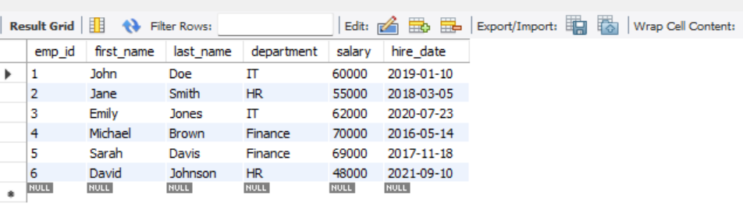

Question.1- Find the average salary of employees in each department.

SELECT department, AVG(salary) AS average_salary

FROM employees

GROUP BY department;

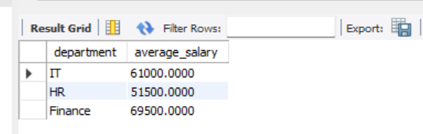

Question.2- Find the total number of employees hired after 2019.

SELECT COUNT(*) AS total_employees_hired_after_2019

FROM employees

WHERE hire_date > '2019-12-31';

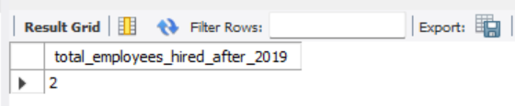

Question.3- List the departments and the total salary of all employees in each department, ordered by the total salary.

SELECT department, SUM(salary) AS total_salary

FROM employees

GROUP BY department

ORDER BY total_salary DESC;

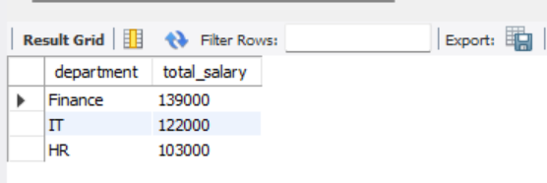

QUESTION.4- Find the highest salary in the Finance department.

select max(salary) as higher_salary

from employees

where department = 'finance';

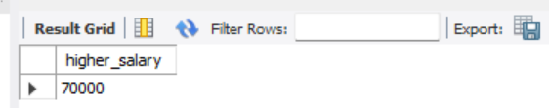

QUESTION.5- Get the top 3 highest-paid employees.

Select *

From employees

order by salary desc

limit 3;

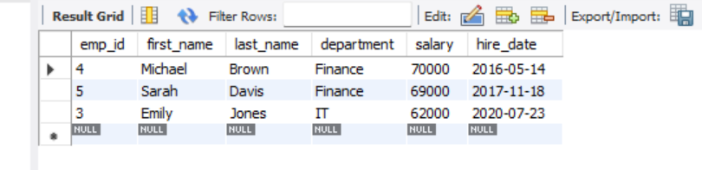

QUESTION.6- Find the department with the minimum average salary.

Select department, avg salary as avrage_salary

From employees

Group by department

Order by avrage_salary asc

Limit 1;

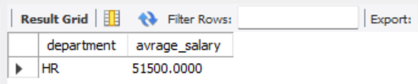

QUESTION.7- Display the total number of employees in each department, ordered by the number of employees.

select department, count(*) as total_employees

from employees

group by department

order by total_employees;

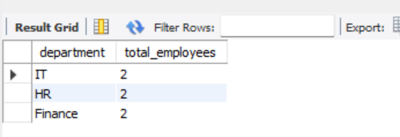

QUESTION.8-Find the average salary of employees who were hired before 2020.

Select department, avg(salary) as avrag_salary

From employees

Where hired_date < '2020-01-01';

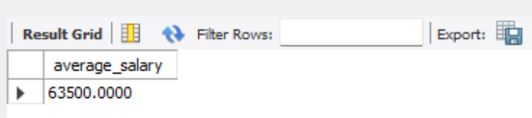

QUESTION.9- **List the names of employees in the IT department ordered by hire date, with the most recently hired employees first.**

**SELECT names;**

**FROM employees**

**WHERE department = 'IT'**

**ORDER BY hire_date DESC;**

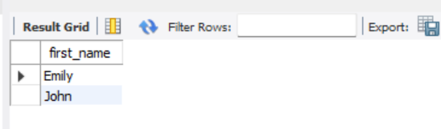

QUESTION.10- Find the sum of salaries for all employees hired after January 1, 2019, ordered by salary.

Select sum(salary) as total_salaries

From employees

Where hired by ’01,01,2019’;

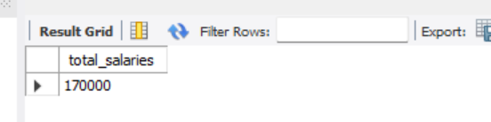

QUESTION.11- **.** Get the employee with the lowest salary in the HR department.

SELECT *

FROM employees

WHERE department = 'HR'

ORDER BY salary ASC

LIMIT 1;

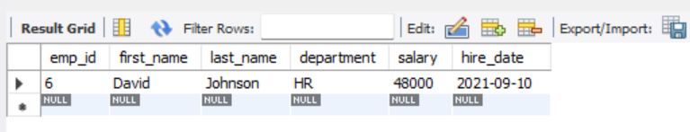

QUESTION.12- Find the total salary paid to employees in each department, but limit the result to the top 2 highest-paying departments.

SELECT department, SUM(salary) AS total_salary

FROM employees

GROUP BY department

ORDER BY total_salary DESC

LIMIT 2;

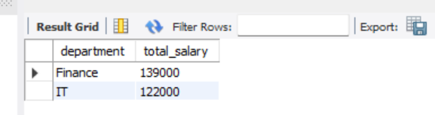

QUESTION.13- List all employees hired after 2018, ordered by salary, and show only the first 4 employees.

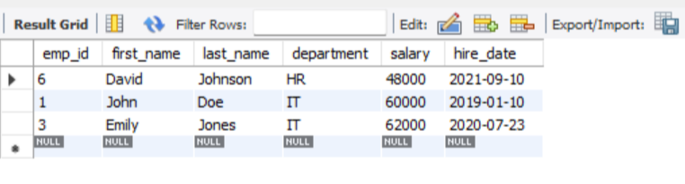

QUESTION.14- Find the highest salary in the IT department, but limit the results to the top 1 result.

SELECT MAX(salary) AS highest_salary

FROM employees

WHERE department = 'IT';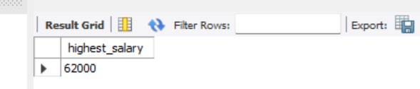

QUESTION.15-Get the average salary of employees in each department and list only departments with an average salary greater than $60,000.

SELECT department, AVG(salary) AS average_salary

FROM employees

GROUP BY department

HAVING AVG(salary) > 60000;

